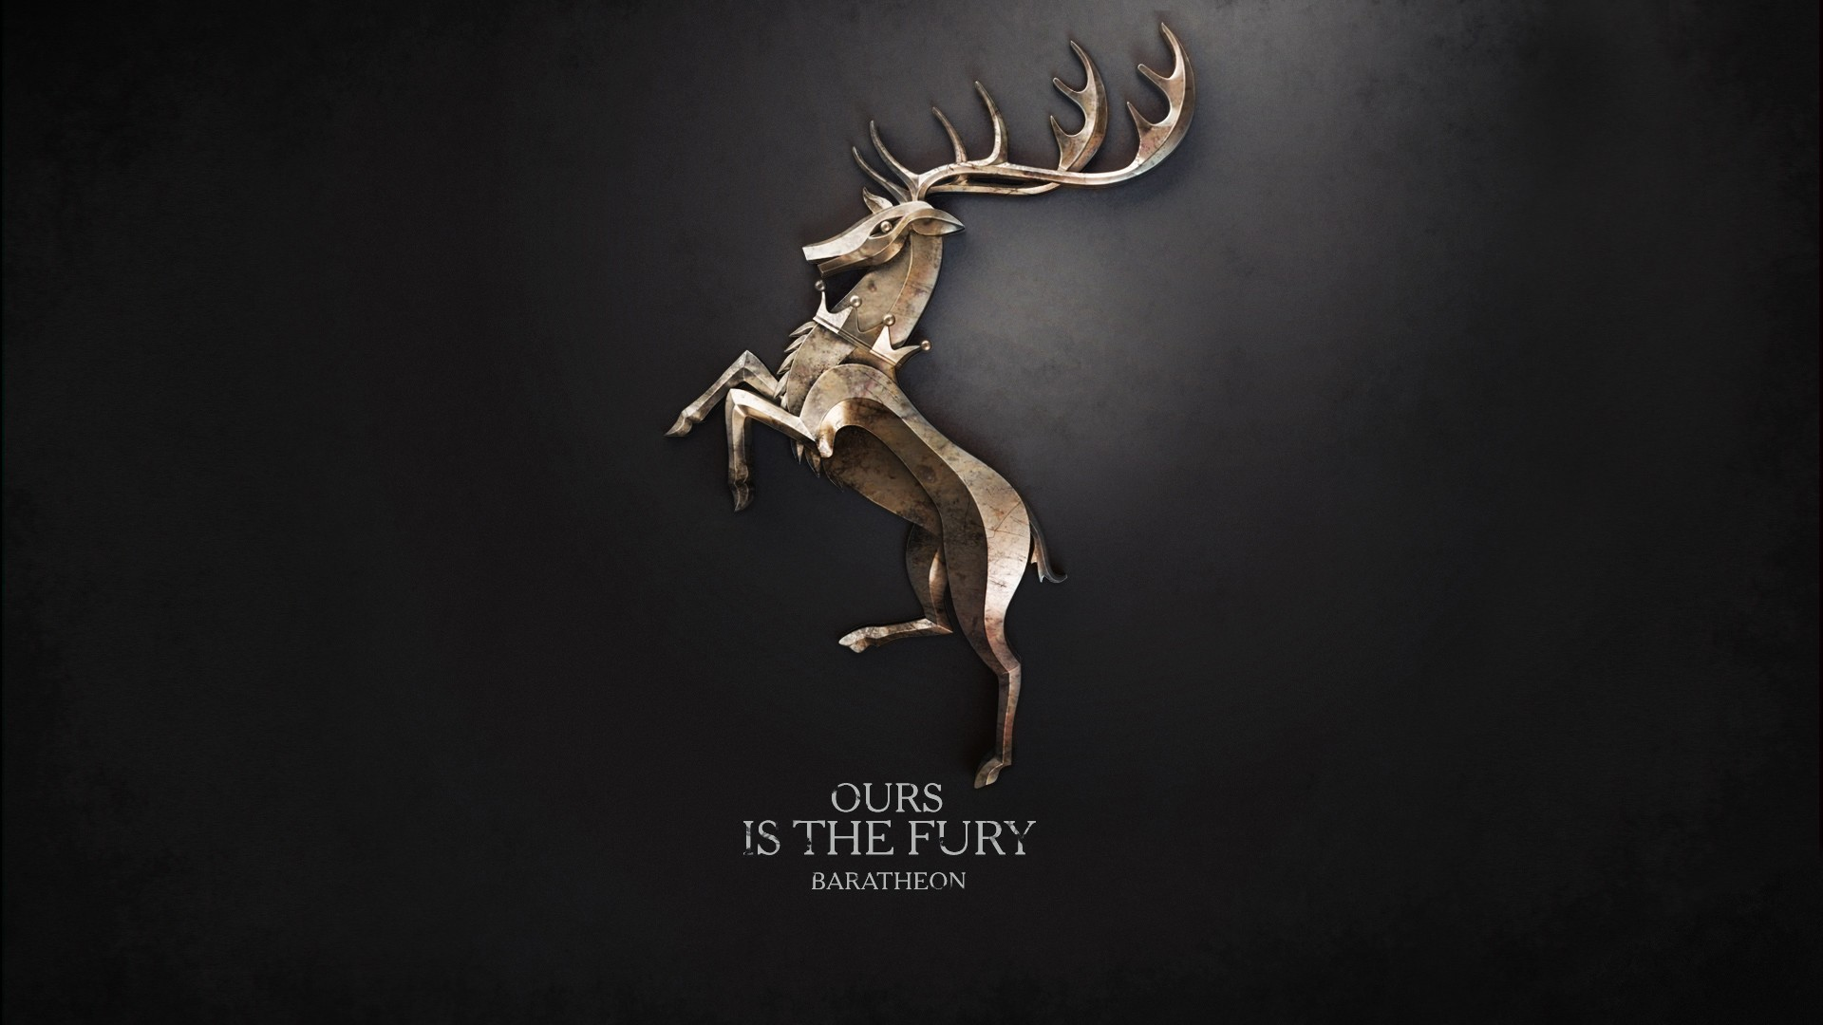

My First Game :

Thank you for Trust Me And give it a try ^_^

It Takes me 7 days to build it as I was normal user love games so much but I didn't stop in Just Playing I decided Try build a game to start my journey in game development as a hobbit

My Name is Mohamed Fathallah and I'm Presenting you

Lost Deer

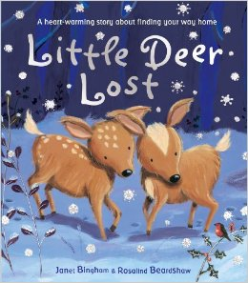

Story:

**Summary:**

This book is about a set of twin baby deer that experience their first snowfall for the first time. The deer, Sparkle and Silver, start off with being excited that they finally get to see snow. They spend some time playing in the snow and loving every second of it. Soon it becomes dark and Sparkle and Silver are ready to head home, but they have a problem. They realize everything looks the same when it’s covered it white snow and soon become lost. Sparkle and Silver get very nervous when it starts to get darker and the wind picks up. Eventually they are reunited with their mom and get to go home. The next day, Silver and Sparkle get to play in the snow with their mom.

<https://www.youtube.com/watch?v=svqBUW9nPP0> URL OF Story.

The Crystal:



It Will move you to next Level to Reach Home

Look Out Of This it will kill you :

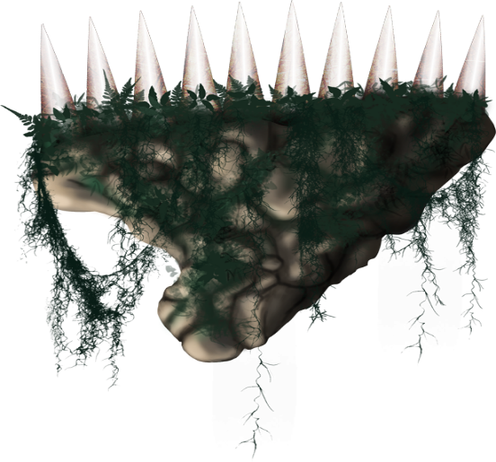

Look Out From The Seashell:

My character:

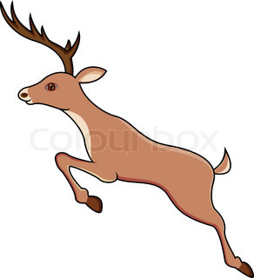

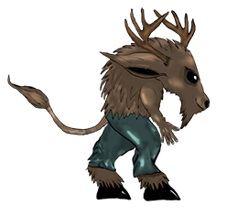

https://www.youtube.com/watch?v=svqBUW9nPP0 ..URL OF Story

Music Used With asset in game ^^.

.